Title of the presentation (Times New Roman 11pt, centered, bold)
A.B. Author¹ and C.D. Author² (presenting author underlined)
1. Affiliation of the first author (full mailing address)
2. Affiliation of the second author (full mailing address)
Presenting author e-mail: ab_author@...
Replace these instructions with the text of your abstract. The paper size is set to A5 format (14.8 cm x 21 cm). Page margins are set for to be one cm on all sides. It should be single spaced Times New Roman,10 pt. The maximum length of the text of the abstract is 1800 characters including spaces (one page).
Figures included into this file must be send separately via e-mail attachment. To avoid technical problems, we suggest using PNG or JPG files for photographs, and encapsulated PostScript (fig1.eps) or PDF for graphs. Captions should not be part of the figures.
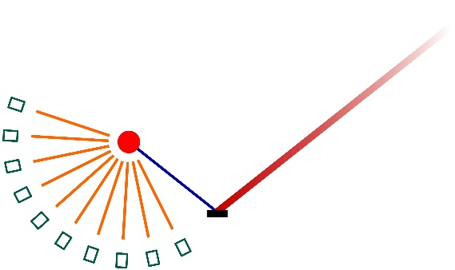
Figure 1. Caption: Times New Roman 9 pt, centered, italicized.
Mathematical formulas should be included by using MS Word equation tool or as a LaTeX code. Structural formulas must be included as a part of text with proper formatting.
Acknowledgments provided by authors can be included at the end of the abstract.
For References use the brief numbered style, e.g. [1, 2]. References should then appear in numerical order in the reference list, and should use the following abbreviated style:
[1] A.B. Author and C.D. Author, Phys. Rev. B, 25 (2023) 112-116
[2] E.F. Author et al., Nature, 612 (2023) 287-290

Additional information: If you have any questions or need additional information regarding the preparation of your abstract send an e-mail to: neutrons2026@ifj.edu.pl

