**Determination of background concentrations of tritium in the freshwater of Fukushima and in the seas around Japan.**

**Shizuho MIKI1,* , Ken Touhata1, Takami Morita1, Yuya Shigenobu1, Toshihiro Wada2, Hyoe Takata2, Kazuyoshi Takasaki3, Yosuke Amano4, and Masamune Endou3**

*1Japan Fisheries Research and Education Agency, 236-8648 Yokohama, Japan*

*2Fukushima University, 960-1296 Fukushima, Japan*

*3Fukushima prefectural Fisheries and Marine Science Research Centre, 970-0316 Iwaki, Japan*

*4Fukushima Prefectural Fishery Office, 970-8026 Iwaki, Japan*

* *e-mail: miki_shizuho48@fra.go.jp*

Tritium is a naturally occurring radioactive nuclide of hydrogen, produced routinely by a nuclear reaction in which cosmic ray-derived neutrons destroy nitrogen and oxygen in the atmosphere. The tritium reaches terrestrial waters through rainfall and flows into the marine environment through rivers. Tritium is also produced artificially by nuclear facilities and released into the marine environment either directly or via the atmosphere and rivers. In Japan in 2011, the Tokyo Electric Power Company Holdings, Inc. nuclear power plant accident occurred and the contaminated water with high concentrations of radioactive nuclides was produced. They removed various nuclides other than tritium from the contaminated water to safe levels to produce the Advanced Liquid Processing System (ALPS) treated water. The ALPS treated water is diluted with a large amount of seawater and then discharged into the sea. As the treated water is diluted by the surrounding seawater after discharge, the concentration of tritium in the seawater is the same as before discharge. It is important to determine the background concentration of tritium in Japan, as the discharge will continue for a long time into the future. In this study, the background concentrations of tritium collected from the Northern Pacific coast of Japan, the Sea of Japan, and the freshwater area of Fukushima Prefecture have been determined.

Seawater and some marine fishes were collected from off Fukushima and the Japan sea by the R/V Soyo-maru, while other fishes and marine algae were obtained through the fisheries cooperatives. Fresh water samples and freshwater fishes, white-spotted char (*Salvelinus leucomaenis*), were taken from the Takigawa Dam reservoir on the Tomioka river basin in Fukushima Prefecture. Tritium in samples were determined according to the method published by the MEXT of Japan (2002). As the concentrations of tritium were low in samples collected in the marine environment, the seawater and water samples in marine organisms were concentrated using a solid polyelectrolyte membrane electrolysis technology. Tritium in samples were then measured by a low background liquid scintillation system.

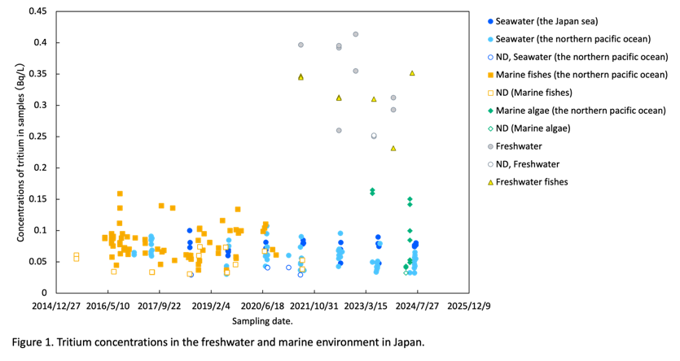In Figure 1, tritium concentrations in the marine environment around Japan have been shown to be low in all cases, lower in marine than in freshwater. The tritium concentrations in water of the Takigawa Dam were <0.26−0.41±0.86, and the TFWT concentrations in white-spotted char were 0.23±0.052−0.35± 0.052. These tritium concentrations were similar to that, 0.50±0.21 Bq/L, in the river water around Japan reported by Sugihara (2009).

MEXT of Japan (2002) version 2.0, Official methods of analysis of tritium. Chiba, Japan Chemical Analysis Center, 127pp (in Japanese).; Sugihara, S. (2009) Distribution of Tritium in River Water. J. Plasma Fusion Res., 85, 429-430 (in Japanese).