Increasing iodine-129 concentrations in the West Philippine Sea
Angel T. Bautista VII,^{1,}* Rachelle Clien G. Reyes¹, Remjohn Aron Magtaas¹, Mary Margareth T. Bauyon¹, Sophia Jobien M. Limlingan¹, Jeff Darren G. Valdez¹, Angela M. De Guzman¹, Eliza B. Enriquez¹, Anne Drew V. Carrillo, Mary Rose P. Gabuyo, Jeffrey C. Munar², Edwin E. Dumalagan Jr.², Caroline Marie B. Jaraula², Fernando P. Siringan², Haruka Kusuno³, Miwako Toya³, Hiroyuki Matsuzaki³
¹Department of Science and Technology – Philippine Nuclear Research Institute, Quezon City, Philippines
²Marine Science Institute (UP-MSI), University of the Philippines, Diliman, Quezon City, Philippines
³Micro Analysis Laboratory Tandem Accelerator (MALT), The University of Tokyo, Tokyo, Japan
*e-mail: atbautistavii@pnri.dost.gov.ph corresponding/presenting author

Iodine-129 (¹²⁹I) is a radioactive isotope with a long half-life, introduced into the environment due to human nuclear activities, such as nuclear weapons testing, nuclear fuel reprocessing, and nuclear accidents. It serves as a useful indicator of nuclear activity impacts, an environmental tracer, and a marker of the Anthropocene epoch. Earlier research involving corals suggested heightened levels of ¹²⁹I in the West Philippine Sea (WPS) and the broader East and South China Sea regions, but the origin of this radioisotope remained unclear. This study presents ¹²⁹I concentration measurements taken from 119 surface seawater samples across various Philippine seas and compares them with existing data from the Yellow, East, and South China Sea to identify the possible source of the increasing ¹²⁹I concentrations in the WPS. Results show that ¹²⁹I concentrations in the WPS, averaging 10.8 x 10⁶ atoms/kg of seawater and ranging from 6.54 to 14.8, are significantly higher, particularly 1.5 to 1.7 times greater (P < 0.0001) than in other areas of the country. The primary source of this increasing ¹²⁹I concentration appears to be located around the Bohai and Yellow Seas. One possibility is that ¹²⁹I from European nuclear fuel reprocessing facilities and historical nuclear weapons testing at Lop Nor and Semipalatinsk is deposited on soils in northeastern China. Rivers then carry these radioactive materials, drain into the Bohai and Yellow seas, and are eventually transported to the WPS through prevailing ocean currents (Fig. 1). Moreover, analysis of a new coral core from the WPS indicates a continuous upward trend in ¹²⁹I/¹²⁷I ratios of about 1 x 10⁻¹² per year from 1971 to 2020, indicating that ¹²⁹I input into the WPS continues to the present. This study underscores the importance of developing policies to tackle transboundary radioactive contamination and highlights the valuable application of ¹²⁹I as a tracer for understanding the complex ocean circulation patterns in the South China Sea region.
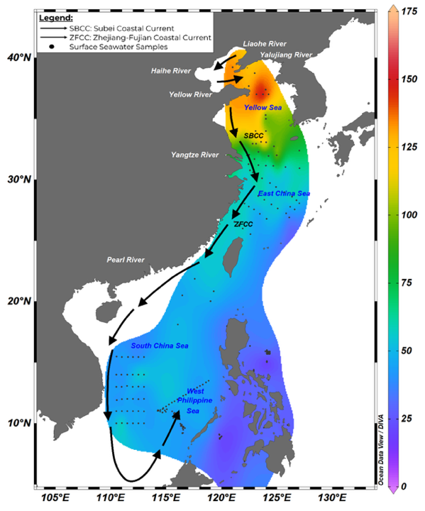
Figure 1. Map of ¹²⁹I/¹²⁷I (x 10⁻¹²) ratios of surface seawater with major ocean currents (Subei Coastal Current or SBCC and Zhejiang-Fujian Coastal Current or ZFCC) possibly transporting seawater with high ¹²⁹I/¹²⁷I ratios to the WPS and the across the region^{This study, 1–4}.

References
1. Wang, Y. et al. Environ Sci Technol 58, 12633–12642 (2024).
2. Zhang, M. et al. Environ Sci Technol 56, 12298–12306 (2022).
3. Burr, G. S. et al. Elementa 8, (2020).
4. Liu, D., Hou, X., Du, J., Zhang, L. & Zhou, W. Sci Rep 6, (2016).

