**The ability of calcium oxalates to incorporate Eu(III) and Cm(III)**

**H. Moll,1,*S. S. Aldin Azzam,1 S. Beutner, 1 M. Vogel, 2 A. Worbs, 3 and R. Hübner3**

*1Institute of Resource Ecology,* *Helmholtz-Zentrum Dresden-Rossendorf, Dresden, 01328, Germany, 2VKTA – Radiation Protection, Analytics & Disposal Rossendorf e.V., Dresden, 01328, Germany*

*3Institute of Ion Beam Physics and Materials Research, Helmholtz-Zentrum Dresden-Rossendorf, Dresden, 01328, Germany*

* *e-mail: h.moll@hzdr.de/presenting author*

Plant cells and plants produce calcium oxalate (CaOx) and store it for instance in vacuoles. There are several functions of CaOx in plants discussed including calcium regulation and detoxification (e.g., heavy metals) [1]. Klotzsche et al. showed for the first time that in the presence of Eu(III), *Nicotiana tabacum* BY-2 cells formed a biomineral composed of Eu(III) and oxalate [2]. This biomineralization could be part of a detoxification strategy for Eu(III) used by BY-2 cells. CaOx can incorporate different cations (e.g. Eu(III) [3]), as well as proteins [4]. To better understand the uptake and behavior of trivalent lanthanides (Ln(III)) and actinides (An(III)) in plants, we first conducted abiotic experiments with Eu(III) and Cm(III) across a concentration range from trace levels to the millimolar scale. Our study aimed to elucidate the speciation of Eu(III) and Cm(III) after incorporation in CaOx using powder X-ray diffraction (PXRD), inductively coupled plasma mass spectrometry (ICP-MS), luminescence spectroscopy, scanning electron microscopy (SEM) coupled with spectrum imaging analysis based on energy-dispersive X-ray spectroscopy (EDXS), and chemical microscopy.

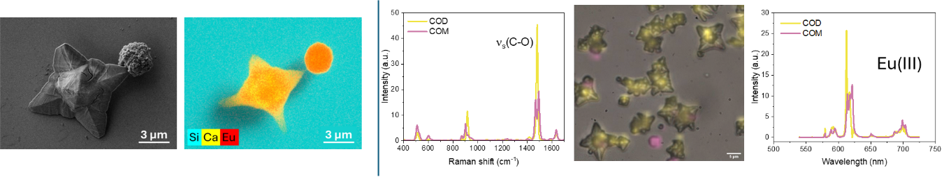

Figure 1. CaOx in the presence of 50 µM Eu(III). Left: SEM image and corresponding element distribution. Right: Results of chemical microscopy (COM/COD: CaOx monohydrate/CaOx dihydrate).

We could show that CaOx has the potential to incorporate large amounts of Eu(III) and Cm(III). More than 90% of the respective heavy metal was incorporated. Eu(III)- or Cm(III)-containing CaOx monohydrate (COM) was formed in the concentration range 0.05 to 5 µM. In the case of Cm(III), an increase in the distance between the interplanar spacing d in Å was observed, the so-called uniform strain effect. At 50 µM Eu(III), both phases, COM and COD were formed and contained Eu(III) (see Figure 1). The luminescence results obtained by using Cm(III) and Eu(III) as molecular probes will be compared and discussed. The obtained results contribute to the overall understanding of the An(III) /Ln(III) uptake by plants.

The authors are indebted to the U.S. Department of Energy for the use of 248Cm via the transplutonium element production facilities at Oak Ridge National Laboratory; 248Cm was made available as part of a collaboration between HZDR and the Lawrence Berkeley National Laboratory (LBNL).

[1] Franceschi VR, Nakata PA. (2005) Annu. Rev. Plant Biol. doi: 10.1146/annurev.arplant.56.032604.144106. [2] Klotzsche, M. et al. (2023) Analyst, DOI: 10.1039/d3an00741c. [3] Lochhead, MJ et al. (1999) J. Phys. Chem. B. 103, 3411. [4] Touryan, LA et al. (2001) J. Cryst. Growth 233, 380.