**In-situ gamma radiation assessment of coastal and hinterland regions of Kanyakumari high background natural radiation area, India**

**Thennaarassan Natarajan,1,* Kazumasa Inoue,1 Sarata Kumar Sahoo,1 Masahiro Fukushi,1 Satoshi Ito,1 Rajamanickam Murugan,2 and P. Duraimaran3**

*1Tokyo Metropolitan University, Tokyo 116-8551, Japan*

*2V.O. Chidambaram College, Tamil Nadu 628008, India*

*3University of Hyderabad, Hyderabad 500046, India*

* *e-mail:* [*nthennarassan@gmail.com*](mailto:nthennarassan@gmail.com)

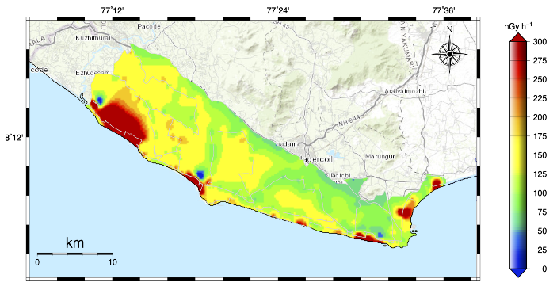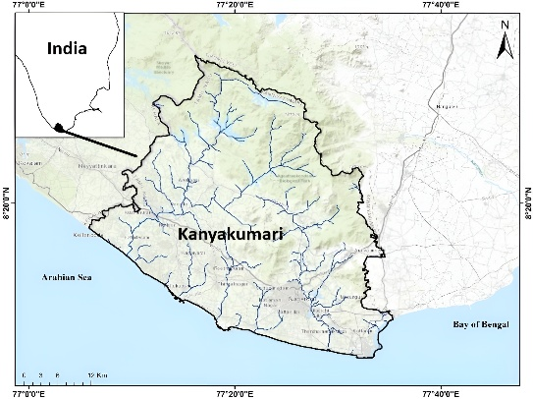Assessing radiological risks to ecosystems, agricultural systems, and public health relies on the absorbed dose rate in air (Dair). Since it may not always be possible to measure and rely solely on point data, combining point data with other methods provides a more comprehensive assessment. Alternatively, the car-borne survey technique allows direct measurement of Dair, providing a thorough assessment of background radiation levels. This study presents the natural gamma radiation survey conducted using a vehicle-mounted NaI(Tl) scintillation spectrometer in the coastal and hinterland regions of Kanyakumari, a high background natural radiation area (HBNRA) in India (Fig. 1). The comprehensive study allowed the authors to distinguish the background radiation levels between the coastal and hinterland regions. Most of the coastal regions exhibited high background natural radiation levels (ranging between 39.11 – 1796 nGy h-1,with a geometric mean of 150.2 ± 211.4 nGy h-1), while a few of the hinterland regions exhibited elevated background radiation levels (ranging between 44.28 – 456.4 nGy h-1, with a geometric mean of 118.6 ± 53.11 nGy h-1). The z-score for the Dair in the coastal area, with 1262 points, suggested 28 extreme outliers and 53 mild outliers, whereas the z-score for the Dair of the hinterland region, with 882 points, suggested 19 extreme and 36 mild outliers. The dose distribution map, created using the 2144 data points, clearly displayed these outliers as hotspots (Fig. 2). The frequency distribution of Dair was right skewed, with the tail extending asymmetrically towards more positive values. The resulting p-value from the t-test was less than 0.05, indicated a statistically significant difference between the dose rates of the coastal and hinterland regions.

**Fig. 2** Absorbed dose rate spatial distribution map

**Fig. 1** Study area map