Remember that the presenting author must be a registered participant. Please fill in the application form below (all points I-VI must be covered).

- Choose the type of your contribution (provide an X sign in the appropriate row of the first column):
Oral
Poster
Oral and Poster

- Name and surname of the presenter: ………

- E-mail of the presenter: ……..

- I attach ….. PDF/PNG/JPG file/files (specify the number of figures attached). Remember that each figure included in the abstract must be sent as a separate file.

- Choose the section of your contribution (provide an X sign in the appropriate row of the first column):
Soft matter and glass-formers
Molecular magnets and nanomagnets
Multifunctional materials
Ferroelectric and multiferroic materials
Spectroscopic and diffraction methods (neutron scattering, dielectric spectroscopy, IR spectroscopy, NMR, Positron Annihilation Spectroscopy, X-ray diffraction, etc.)
Structure research
Computational physics
Miscellany (biologically oriented systems, new ideas, advanced materials, surfaces, interfaces, ceramics, hydrogen storage, energy storage, etc.)

- Please provide up to 5 keywords: ……….

The poster or oral contribution title (Font: Calibri, 12 pts, Bold, Center the text). Above and below the title the free space lines of 12 pts should be left.

A. First-Author-Name¹, B. Second-Author-Name², C. Next-Author-Name³, …, D. Last-Author-Name^{N}

¹Name of the Institute or University, City/Town, Country
²Name of the Institute or University, City/Town, Country
³Name of the Institute or University, City/Town, Country
…
^{N}Name of the Institute or University, City/Town, Country

Email: alternatively-give-email@of-presenting-author

The authors’ section: Font: Calibri, 11 pts, Center the text. Between the authors’ names and the affiliation section, the free space line of 10 pts must be left. The presenting author must be underlined. The affiliation section: Font: Calibri, 10 pts., Justify the text to the left side. There is no need for providing the street name or the zip code. An e-mail of the presenting author can be given below the affiliation section (Font: Calibri, 10 pts., Justify the text to the left side). The free space lines of 10 pts must be left between the affiliation section and the email line, and between the email line and the text of the abstract. The 1 cm left and right indents must be used in the author, affiliation, and email sections. No free space line should be given between the paragraphs.
The abstract text must be written in single-spaced paragraphs with 11 pts characters using the Calibri font. Justify the text on both sides. The 5 mm left indent should be placed at the beginning of each paragraph. The safest option to avoid formatting errors is to paste the text of your abstract over this one as plain text without any formatting. Use 2.5 cm margins (left, right, upper, and bottom). Do not change line spacing or margins.
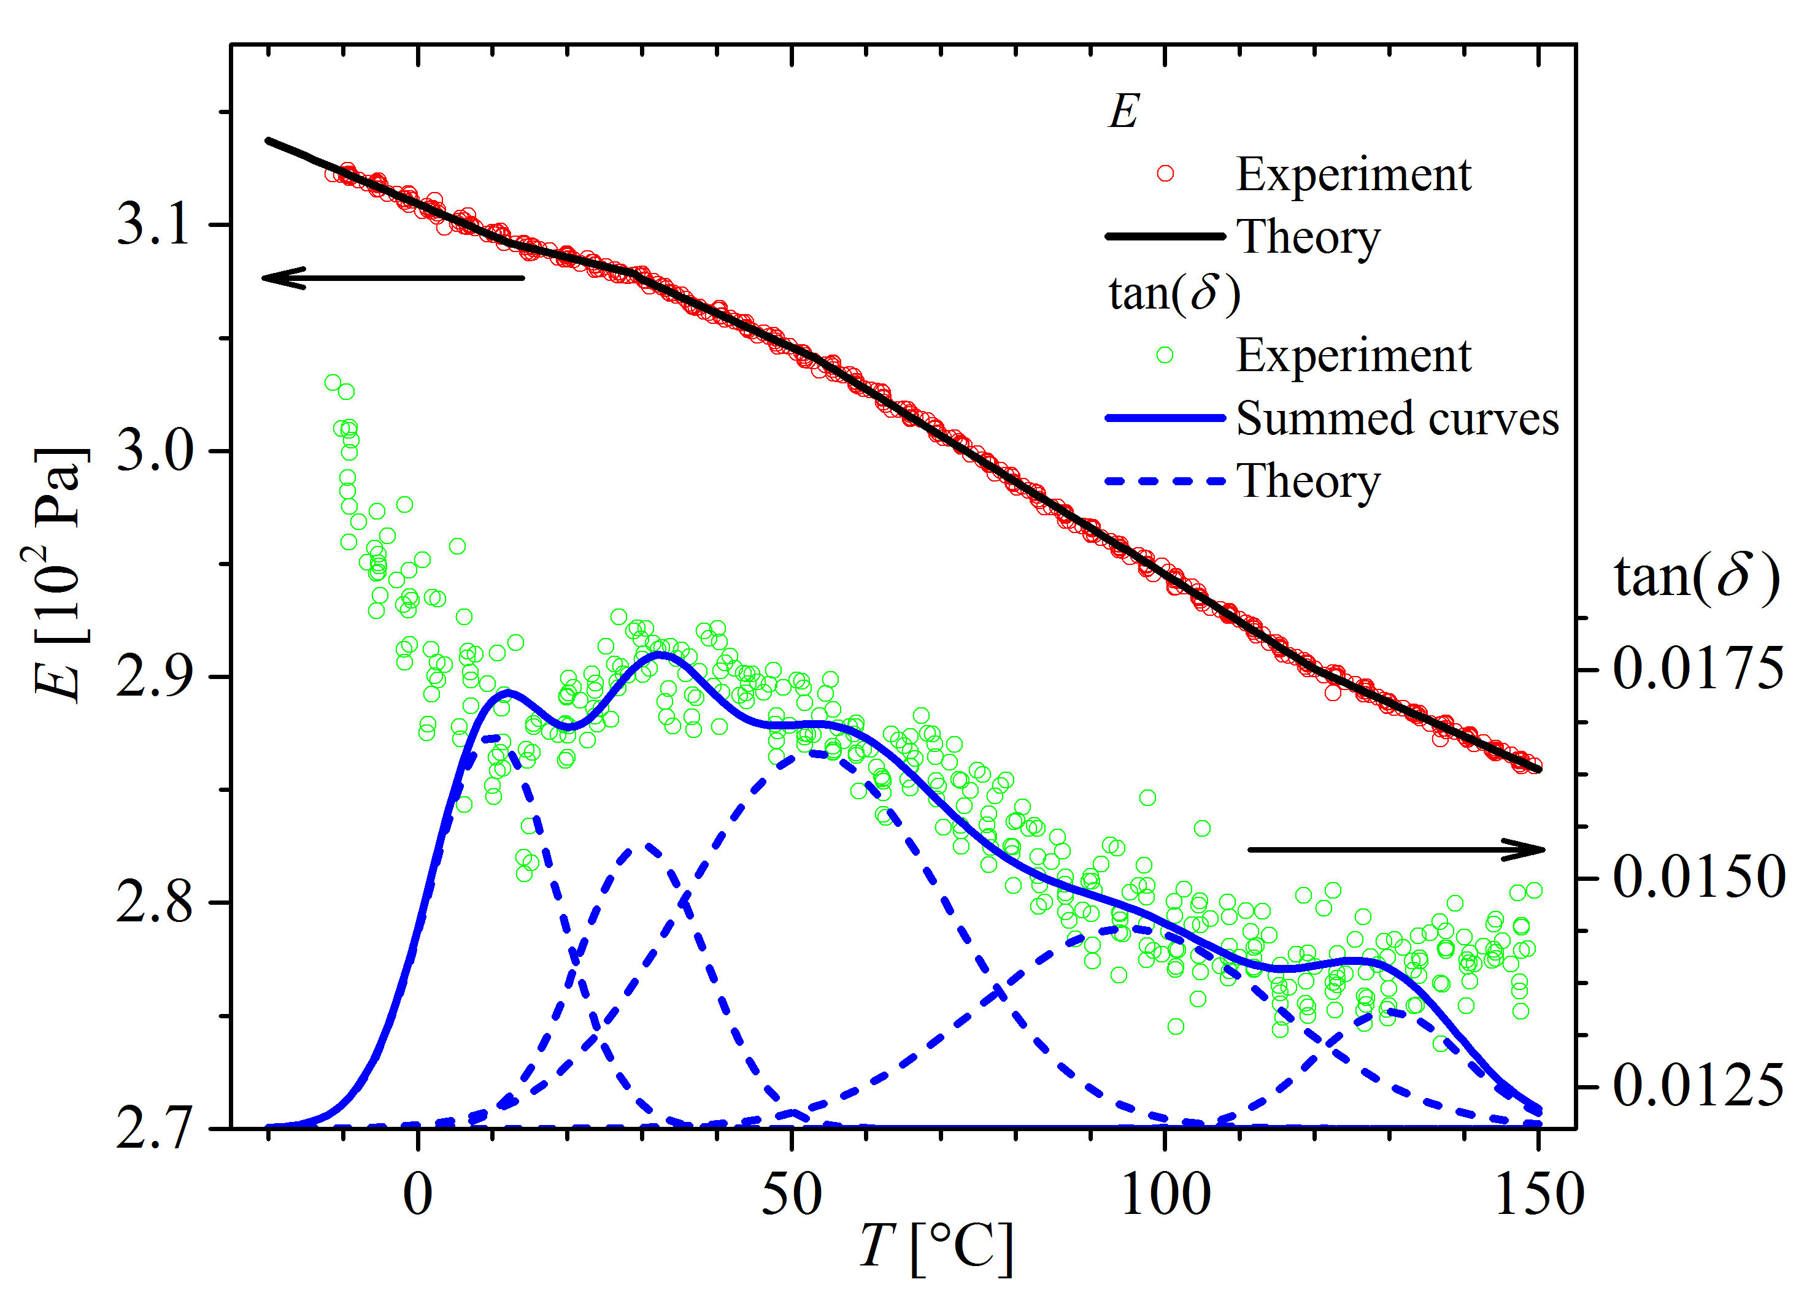
If you need to add special characters (ä, ñ or ë, etc.) or Greek letters (α, β or ω, etc.), please add them from the Calibri repertoire (Insert-Symbol), and not from any other font you may have installed in your computer. Your special characters can be lost if the font you used is not installed in our processing system. Any equation(s) must be inserted from the Word menu via the Insert-Equation command.
If you want to include images or graphics in your abstract, insert them into the document using the frame option of text wrapping with at least 2.5 mm text distance, as shown in the example of Fig. 1 on the right-hand side. In addition, the file with the image/graphic should be sent separately as a PDF, PNG or JPG file.
References should be quoted in the text like this.⁽¹⁾ Use the citation style shown below.⁽²⁾ All positions listed in the reference section should be quoted in the text.
Fig.1 Font: Calibri, 8 pts, Italics. The figure caption must be provided using the text field option. Justify the text on both sides. Figure must be quoted in the text.
The abstract size is restricted to a single A4 page. The file should be named: YoungMultis2023 – Name and Surname.

Acknowledgments: leave a free space line of 11 pts between the text and the acknowledgment section. Use the same font, font size and spacing as in the abstract body. Do not use the indent in the first line. Leave the free line space of 11 pts between the acknowledgment and the reference section.

⁽¹⁾ A. First-Author-Name, B Second-Author-Name, Journal Abbreviation Vol. (Year) First-Page (Font: Calibri, 10 pts, Justify text on both sides)
⁽²⁾ A. First-Author-Name, et al., Journal Abbreviation Vol. (Year) First-Page (Font: Calibri, 10 pts., Justify text on both sides, for articles/books with more than two authors)

